Donor Communication 2023

The Massachusetts Immigrant Collaborative's Heartfelt Event Commemorating 3 Years of Progress

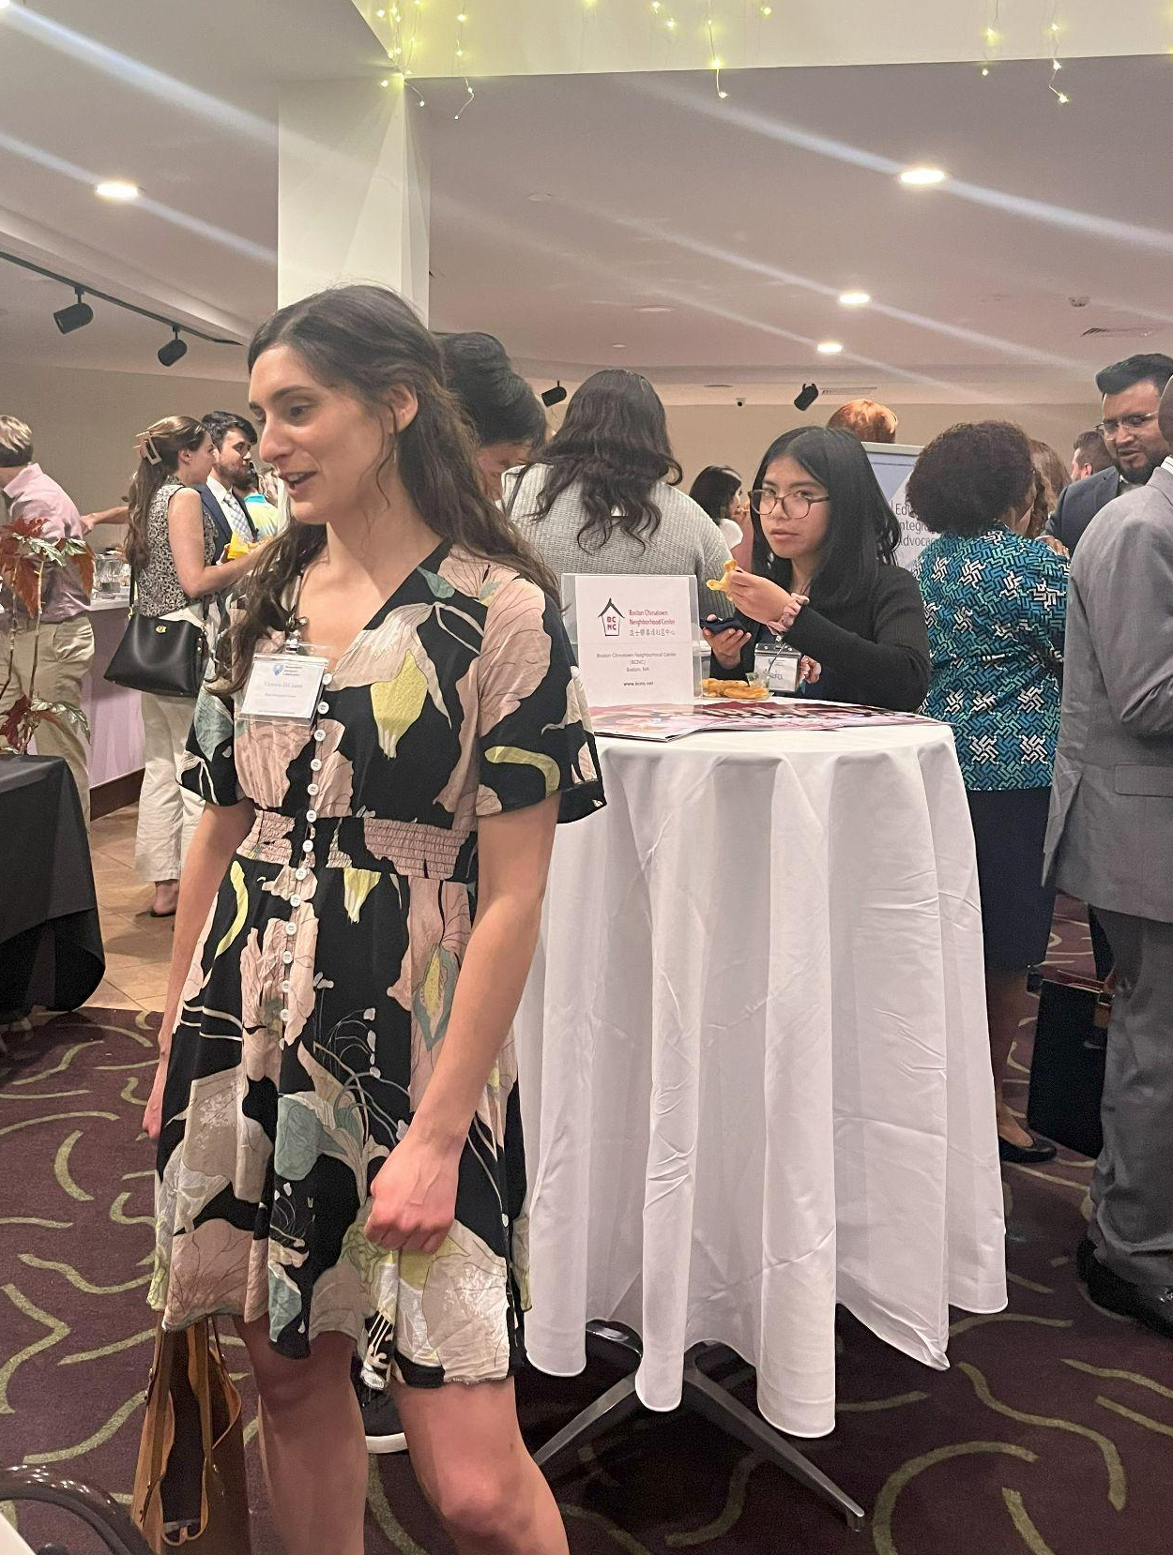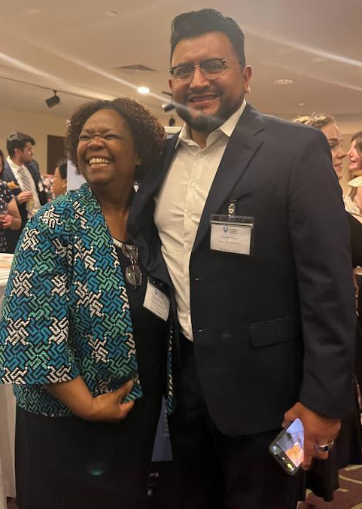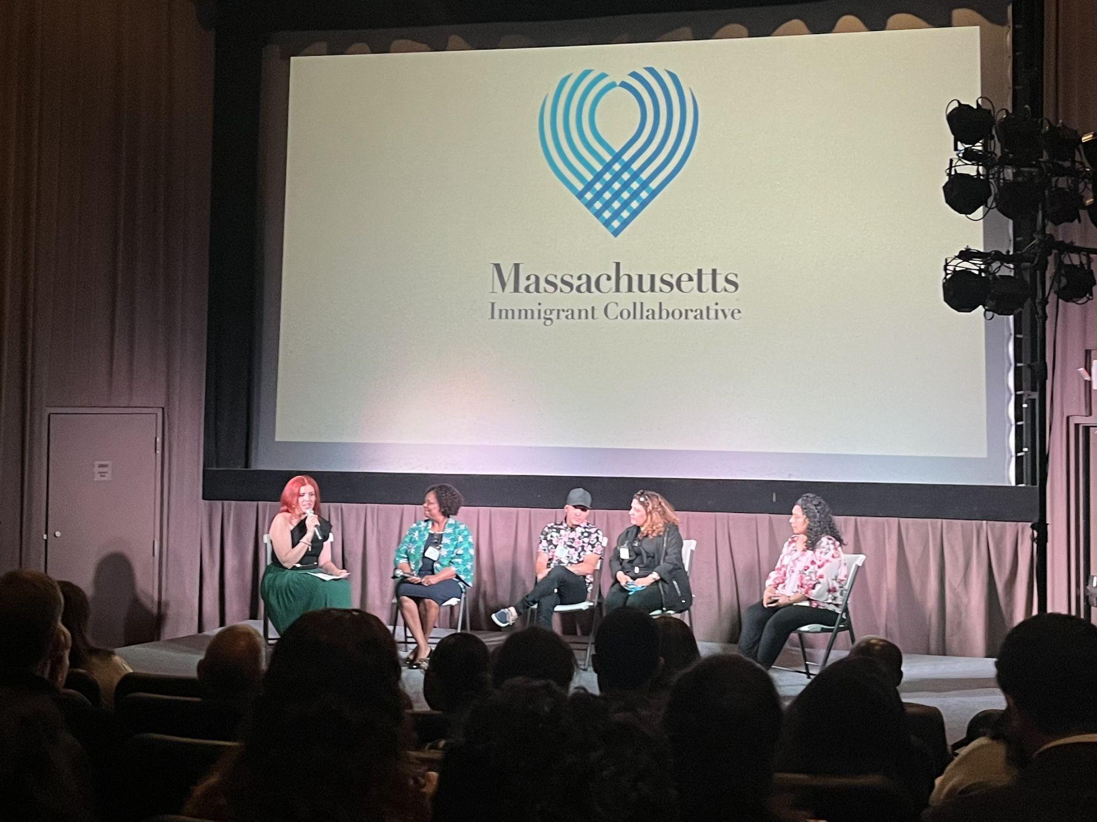

The Massachusetts Immigrant Collaborative's Heartfelt Event Commemorates 3 Years of working alongside immigrant families in Massachusetts.
The third anniversary of the Massachusetts Immigrant Collaborative was a truly special evening, filled with a sense of accomplishment, learning and celebration. Following the screening of two powerful documentary films, "Waiting To Continue”, the story of Venezuelan asylum seekers on Martha’s Vineyard; and "A Glimmer in the Heart of the Exile", the story of families leaving hardship in Haiti and finding community in Massachusetts; attendees heard inspiring stories from community members. The evening concluded with a reception celebrating the exceptional initiatives of the Collaborative’s partners.

Achieving Milestones: Delivering Exceptional Legal Services
Launched in August of last year, the Collaborative’s Centralized Legal Services Program has positively impacted the lives of nearly 400 immigrant families. Through our legal partners, Agencia ALPHA, Mabel Center, and Rian Immigrant Center, we are proud to have provided 362 consultations on immigration concerns, empowering individuals to better understand their legal rights and determine if they are eligible for immigration legal benefits. Our legal partners are providing full representation on 93 cases ranging from complex asylum to simpler Temporary Protected Status (TPS) applications and renewals and Permanent Residency and Citizenship applications for community members like Marie, who shares her story below.

Agencia ALPHA and MICollaborative Extend a Helping Hand to Marie
Marie was in the process of moving to a new apartment when movers lost her identifying documentation including her green card. Without a Massachusetts ID Marie couldn’t prove she was a legal resident and in turn, didn't qualify for Medicaid. Every aspect of Marie’s life was affected, and having recently retired, Marie was relying solely on her Supplemental Security Income and was not able to afford an immigration attorney.

With help from her long-time friend Linda (Marie had been Linda’s mom’s home health aide and they had remained friends for over 20 years), Marie was connected to Agencia ALPHA through the Massachusetts Immigrant Collaborative's Centralized Legal Services Program. This program specializes in providing culturally competent legal services to the Collaborative’s partners' community members, offering support to individuals like Marie who are navigating complex immigration procedures. Despite the holiday season posing challenges in finding assistance, Vilma from Agencia ALPHA promptly responded to Linda and Marie's inquiry. Says Marie, “[Vilma] was very lovely. She was very patient. She was very thorough.”

Luckily, an error in Marie’s application was quickly resolved by Vilma and didn't affect her petition for a new green card. This took a big weight off Marie’s shoulders. Marie is especially grateful for Agencia ALPHA’s and the Collaborative’s guidance, “I'm so grateful for everything [you have] done for me.” She now looks forward to continuing on her path to becoming a citizen.

Immigrant families receive emergency assistance from the Collaborative
Thanks to support from the Klarman Family Foundation, as well as the Cambridge Community Foundation and The Boston Foundation (through the Executive Office of Housing and Economic Development’s (EOHED) Community Foundations Grant Program for COVID-19 Relief), the Collaborative and its partners provided food and emergency cash assistance to 3,587 immigrant families who continue to experience economic hardship since the pandemic ended. Close to 90% were struggling to pay rent and utilities, and buy food and groceries. Other needs included medical and childcare expenses. According to one immigrant activist who is part of a large network of immigrants, “These resources have made the difference between being housed and unhoused, access to medicines and critical medical care, childcare, and legal services. The significant and necessary work of MIC is sacred work and our families are deeply grateful as we work for a society in which everyone has what we need for lives of dignity and flourishing. Thank you! “

Mass Immigrant Collaborative to serve as Administrator of the City of Boston’s Immigrant Economic Advancement Initiative
The City of Boston chose the Massachusetts Immigrant Collaborative to take the lead in the Immigrant Economic Advancement Initiative which will support 200 Boston immigrant families. We will be working with our partners to launch the initiative in January.

Driver’s licenses available to immigrant drivers July 1st
As of July 1, eligible immigrants living in Massachusetts can apply for driver’s licenses and learner’s permits regardless of their immigration status. Led by the Brazilian Worker Center, SEIU 32 BJ and the Driving Families Forward coalition, we joined forces to successfully advocate for the passage of the Work and Family Mobility Act. Passage of this bill was a huge success. We are all delighted that after 20 years of advocacy, the Work and Family Mobility Act has come to pass.
Cristina Aguilera Sandoval to lead the Office for Refugees and Immigrants (ORI)
Finally, in June, Governor Maura Healey, Lieutenant Governor Kim Driscoll, and Health and Human Services Secretary Kate Walsh announced the appointment of the Collaborative’s Executive Director Cristina Aguilera Sandoval to serve as Executive Director of the Massachusetts Office for Refugees and Immigrants (ORI). Though we are sad to lose a leader with passion, dedication and keen oversight, we are thrilled that ORI will have a director devoted to advancing opportunities, policies and equity for immigrants and refugees in Massachusetts and beyond. Says Cristina, “I am honored and humbled to join Governor Healey’s administration. At a time when so many people are displaced by conflict, persecution, failed economies, and climate change impacts, including my family, this country is seen as a beacon of hope. Massachusetts prides itself in being a welcoming state, and together, we can ensure that we live up to our values.”

Plans for the Collaborative’s next steps are underway and we will share updates as they progress.
Warm regards,
Janey Tallarida
Massachusetts Immigrant Collaborative
www.ImmigrantRelief.org/about

